Template

Outline

The first section of the RAD is an Introduction. Its purpose is to provide a brief overview of the function of the system and the reasons for its development, its scope, and references to the development context (e.g., reference to the problem statement written by the client, references to existing systems, feasibility studies). The introduction also includes the objectives and success criteria of the project.

// brief overview of the function of the system

The system’s main function is to provide student-oriented software to reduce parking congestion. The software solves the problem by interfacing users and drivers. Users will be able to signal for open parking spots. Its development will mitigate student and faculty frustration while increasing positive traffic flow. This will direct drivers to open parking spots and decrease the overall time required to find parking.

The reason for its development stems back to the growing congestion problem at the university. Traffic is dynamic and bottlenecks develop frequently and without notice. The university has proposed turning Elmwood Park Road’s intersection into a roundabout to reduce congestion. UNO is also currently doing intersection modifications on 67th and Pacific to facilitate traffic movement between campuses. Mobile software is popular and ubiquitous among young adults. UNO can use this technology to their advantage. Mobile technology can serve as a fighting plane to fight traffic congestion.

The scope of the software will entail all of UNO’s campus. The development context includes students, faculty, and the surrounding traffic. UNO and the surrounding community are considered the stakeholders. The software will seek to meet stakeholder needs by reducing congestion while satisfying users by delivering a quicker parking scenario.

(e.g., reference to the problem statement written by the client, references to existing systems, feasibility studies).

The objective is to create a software to alleviate parking congestion at UNO. This objective will be completed via a website interacting with mobile devices. Users will be able to sign-up onto this application with their UNO email account. The user will also be able to store a vehicular photo. The main piece of the website will be an interface between drivers and users. Users will be able to simply notify the website of their intention to leave a parking spot and provide the website with their GPS location. The website will display a live aerial traffic map to drivers. This map will show users leaving their parking stall. As drivers approach the location, they will be able to request the parking spot.

Upon the parking stall request, the leaving user will be notified of the request via their mobile device. The user may accept any of these driver applications. At this point, there is a user-driver financial transaction. This financial transaction transfers some small fee from the driver to the leaving user. The transaction costs may increase as the number of users surge.

After the transaction, users and drivers may rate their transacting user out of five stars. Users may even leave a comment about the other user. Upon any requests, the website will display the user rating with their vehicular photo. Previous comments will be shown under the user’s photo. In the case of a failed transaction, the driver may request and receive an immediate refund.

The introduction also includes the objectives and success criteria of the project.

Success criteria will include the successful user-driver transactions. For this to occur, drivers and user must be able to interact through the application. User must be able to declare their desire to leave, and the application must notify drivers of user locations. The transactions must then be monitored. In the case of a failed transaction, the driver must be able to request and receive an immediate refund. The software favors the frustrated driver’s experience, trusting that this will bring the highest overall user satisfaction.

Definitions, acronyms, and abbreviations

The following clarifies and defines the context of many of the terms described above. Traffic congestion is measured the number of moving vehicles on UNO’s campus. Traffic congestions will be the accumulation of drivers looking for parking spots and users driving off campus. Drivers are those actively driving to or on campus in search for a parking stall where they may park. Users are those leaving their parking spots. An aerial map is a satellite plan view of campus. Financial transaction in the web-app includes the transfer of money from the driver to the leaving user party. Refunds may be cancelled transactions or new transactions to pay back payments made to the driver.

2. Current system

The new system facilitates traffic flow, but the current system has no way to facilitating traffic congestion. As with any parking lot, traffic moves as people leave and come, bunching together in popular areas and filling in open parking stalls. The new system will complement the new system, working alongside to improve traffic flow. The problem with the current state of affairs is that there is no management of the traffic flow. Right now traffic is undirected and flows where is wishes. The new system manages who gets the parking spots, but the old system doesn’t.

The new system rewards good and compliant drivers and provide financial incentives, while the current system rewards aggressive driving. In the current system, the parking spot is free to whoever gets it first. This system rewards aggressive maneuvering for parking spots, which motivates driving aggression. The current system also rewards drivers who wait for opening parking spots. The longer drivers wait, the more likely they are to secure a parking spot in their area of interest. This encourages patient driving, but the option is slow. When time is money, waiting for parking stalls is no viable fix. Patient drivers are also not always rewarded; as more aggressive drivers may still take newly unoccupied parking stalls.

The new system allows for effective communication between drivers, but communication is not a viable option in the current system. Communication between drivers rarely occurs, because everyone is vying for the parking spot. Since parking spots are a limited resource and their demand is high, they are seen as a valuable commodity to the frustrated driver. All drivers desire the resource and see their desires as equally important. This makes driver uncaring about other drivers. This makes communication unhelpful in solving the parking spot dilemma. To add to this, drivers avoid communication. Drivers prefer not to interact with other, possibly angry drivers and would rather keep to themselves.

The new system guides drivers to open parking stalls by informing them of future open parking stall locations. The old system provides no information about future open parking stalls. This leaves drivers unawares as where they should drive to obtain a parking stall. This leaves finding a parking stall more to chance and results in students and faculty being late for class.

The second section, Current system, describes the current state of affairs. If the new system will replace an existing system, this section describes the functionality and the problems of the current system. Otherwise, this section describes how the tasks supported by the new system are accomplished now.

3. Proposed system

The main actors are the driver and the user. The driver’s goal is the obtain a parking spot quickly. To accomplish this, the driver needs the user for finding parking spots. In turn, the user obtains financial reward from the driver. The user trusts that the driver will provide the financial incentive based on positive ratings. The goal oriented requirements engineering model is shown below.

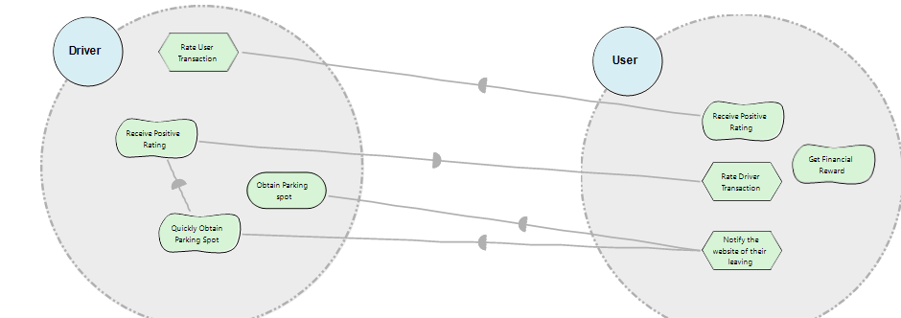

Figure 1. ODME Goal Oriented Requirements Engineering Diagram

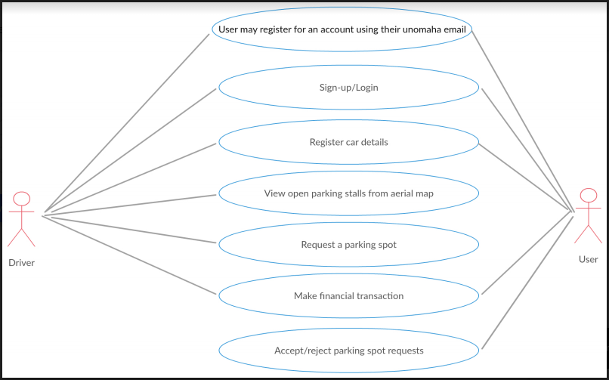

The third section documents the requirements elicitation and the analysis model of the new system.

3.1 Overview

The overview presents a functional overview of the system.

**User Notification Capabilities**

Users may notify all drivers of their intention to leave an open parking spot

**Driver Request Functionality**

The driver may request a particular parking spot for a certain price.

**User Transaction**

Users may undergo a financial transaction for the allotment of the parking spot

**Review Capability**

Users and drivers may review other user and drivers they undergo transactions with

3.2 Functional requirements

Functional requirements describes the high-level functionality of the system.

***Gherkin Here

3.3 Nonfunctional requirements

3.3.1 Usability

3.3.2 Reliability

3.3.3 Performance

3.3.4 Supportability

3.3.5 Implementation

3.3.6 Interface

3.3.7 Packaging

3.3.8 Legal

Nonfunctional requirements describes user-level requirements that are not directly related to functionality. This includes usability, reliability, performance, supportability, implementation, interface, operational, packaging, and legal requirements.

3.4 System models

3.4.1 Scenarios

3.4.2 Use case model

3.4.3 Object model

3.4.4 Dynamic model

3.4.5 User

interface navigational paths and screen mock-ups

System models describes the scenarios, use cases, object model, and dynamic models for the system. This section contains the complete functional specification, including mock-ups illustrating the user interface of the system and navigational paths representing the sequence of screens. The subsections Object model and Dynamic model are written during the Analysis activity.

4. Glossary

A glossary of important terms, to ensure consistency in the specification and to ensure that we use the clients terms.